**FASHION HEAVEN**

**INTRODUCTION:**

Fashion Haven, an online retail store, leverages Zoho Books to manage their inventory and track sales. They can generate invoices and manage customer payments seamlessly. Zoho Books also enables them to reconcile bank transactions and generate financial reports, helping them make informed decisions about their business.. Fashion Haven is a Private Limited company also registered under GST in Tamil Nadu. Fashion Haven is a retailor of various lifestyle products in wholesale and retail, it has a wide range of customers (B2B & B2C) all over the state and it procures from various suppliers in the state. It operates at a Gross Profit margin of 50%.

**PURPOSE:**

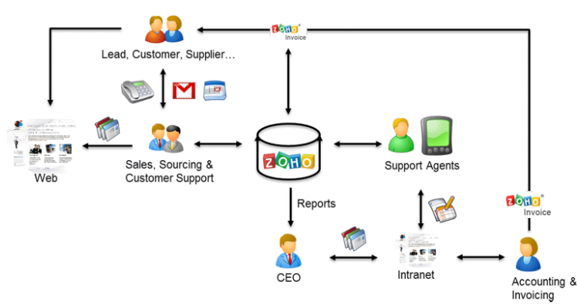

1. **Problem Definition & Design Thinking**

**EMPATHY MAP:**

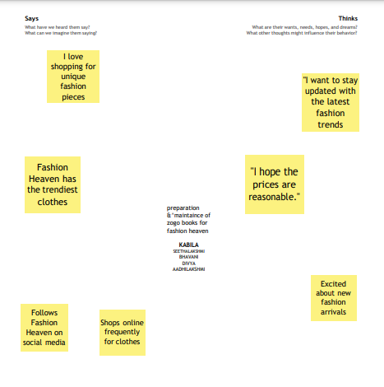

**BRAINSTROME:**

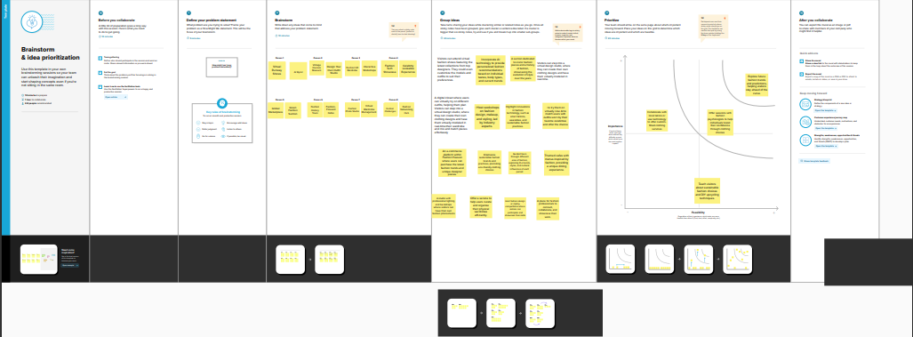

**RESULT:**

**PROFIT AND LOSS;**

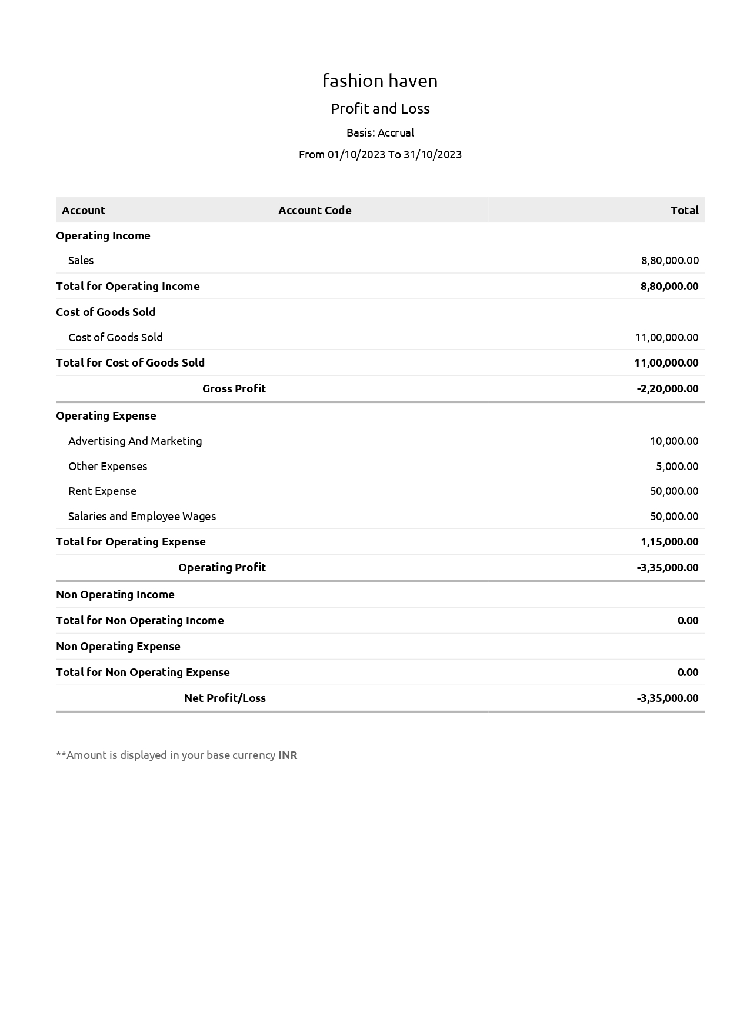

**BALANEC SHEET:**

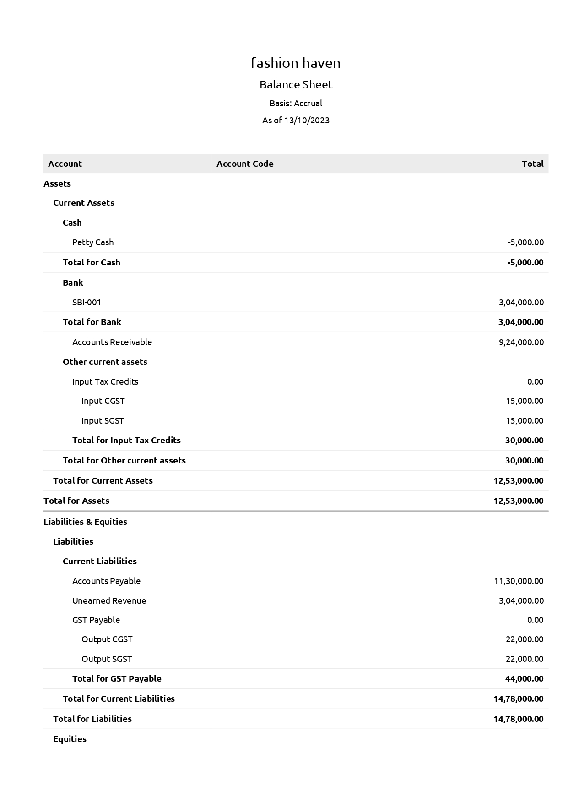

**PURCHASE ORDER:**

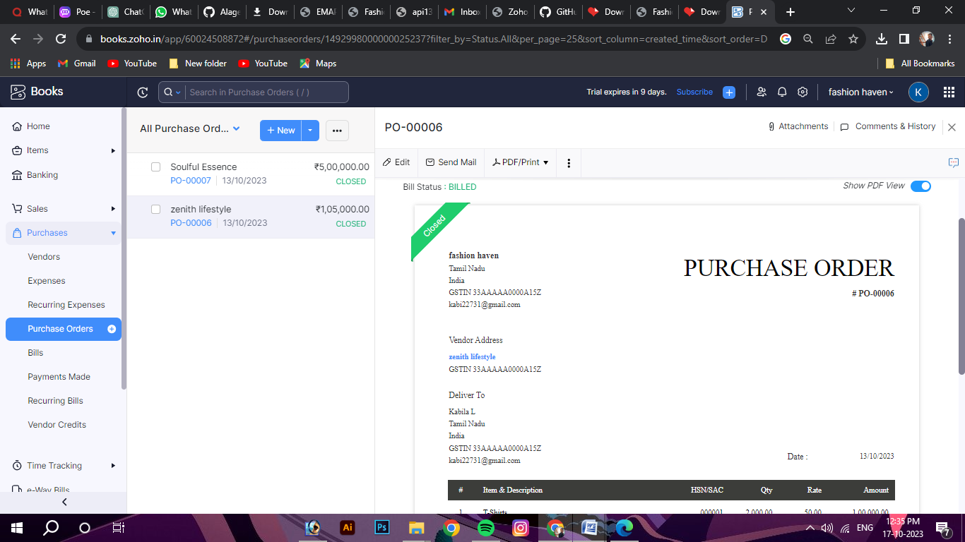

**ADVANTAGE:**

1. **Creative Expression: The fashion industry allows individuals and designers to express their creativity and artistic vision through clothing, accessories, and styling.**
2. **Economic Contribution: The fashion industry is a significant contributor to the global economy, providing employment opportunities and generating revenue through manufacturing, retail, and related sectors.**
3. **Trendsetting and Influence: The fashion industry has the power to set trends and influence popular culture. It shapes consumer preferences and drives demand for new styles and products.**
4. **Global Connectivity: Fashion brings people from different cultures and backgrounds together. It promotes cross-cultural exchange and fosters a sense of interconnectedness through the sharing of design inspirations and trends.**

**Disadvantages:**

1. **Environmental Impact: The fashion industry is associated with significant environmental issues, including waste generation, pollution, and excessive resource consumption. The production and disposal of clothing can contribute to climate change and other ecological challenges.**
2. **Labor Practices: The fashion industry has faced scrutiny regarding labor practices, particularly in the manufacturing stage. Issues such as low wages, poor working conditions, and exploitation of workers have been reported in certain regions.**
3. **Fast Fashion and Consumerism: The rise of fast fashion has led to increased consumption and a culture of disposability. This can contribute to overconsumption, waste, and a disregard for sustainable practices.**
4. **Unrealistic Beauty Standards: The fashion industry has been criticized for promoting unrealistic beauty standards, which can negatively impact body image and self-esteem. It has been associated with issues such as body shaming and lack of diversity and inclusivity.**

**APPLICATION:**

1. **Fashion Design: Fashion designers create apparel, accessories, and footwear, applying their creativity and design skills to develop unique and visually appealing products.**
2. **Retail and Merchandising: Fashion retailers curate and display clothing and accessories in stores or online platforms, ensuring an attractive presentation and effective merchandising to drive sales.**
3. **Fashion Marketing and Branding: Marketing professionals within the fashion industry promote brands, products, and collections through various channels, such as advertising, social media, and influencer collaborations.**
4. **Fashion Journalism and Media: Fashion journalists and media professionals cover industry trends, events, and news through print, online publications, blogs, or broadcast media, providing insights and analysis to a wider audience.**
5. **Fashion Styling: Fashion stylists work with individuals, brands, or publications to create visually compelling outfits and looks for fashion shows, photoshoots, advertisements, or personal styling services.**
6. **Fashion Photography: Fashion photographers capture images that showcase fashion products, models, or campaigns, creating visually appealing and impactful visuals for marketing and promotional purposes**

**Conclusion:**

**In conclusion, the fashion industry offers a wide range of applications and career opportunities. From fashion design and retail to marketing, media, and styling, there are various avenues for individuals to express their creativity and contribute to the industry. The fashion industry has a significant economic impact, driving revenue and employment opportunities globally.**

**However, the industry also faces challenges. Issues such as environmental impact, labor practices, fast fashion, and unrealistic beauty standards have been raised and require attention and action from industry stakeholders. It is crucial for the fashion industry to prioritize sustainability, ethical practices, diversity, and inclusivity to address these concerns.**

**While specific information about "Fashion Heaven" and its applications was unavailable, it is important to conduct further research and gather detailed information about the entity to understand its unique applications and contributions within the fashion industry.**

**Overall, the fashion industry continues to evolve and adapt to changing consumer demands and market trends. It offers a dynamic and creative landscape for individuals to pursue their passion and make a meaningful impact in various fashion-related fields.**

**future scope:**

**The future scope of the fashion industry is influenced by several emerging trends and advancements. Here are some potential areas of development and growth:**

**Sustainable Fashion: As environmental concerns continue to rise, there is a growing demand for sustainable and ethical fashion practices. The future of the industry lies in embracing eco-friendly materials, reducing waste, promoting circularity, and implementing ethical supply chain practices.**

**Technology Integration: Technology is playing an increasingly significant role in the fashion industry. Advancements such as virtual reality (VR), augmented reality (AR), 3D printing, and artificial intelligence (AI) are transforming various aspects, including design, production, retail, and customer experience.**

**Digital Transformation: E-commerce and online platforms have revolutionized the way consumers shop for fashion. The future will see further digital integration, including personalized online experiences, virtual try-on, and enhanced customization options.**